Bake on a rainy day.

Paddle in the water.

Play a boardgame or draw hopscotch or x/o’s in chalk.

Go for a walk in a forest, find an interesting stick!

**Lie on the grass and watch the clouds**(what shapes can you see?)

Play in the sand at the beach, write your name in the sand, build a sandcastle. 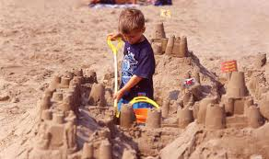

Go out on your bike/scooter/skateboard. 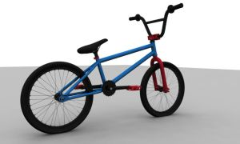

Plant something or water some plants. 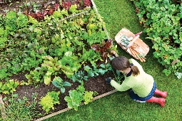

Visit the beach, pick up some litter.

Use gloves or a litter picker!

Make a nature picture. 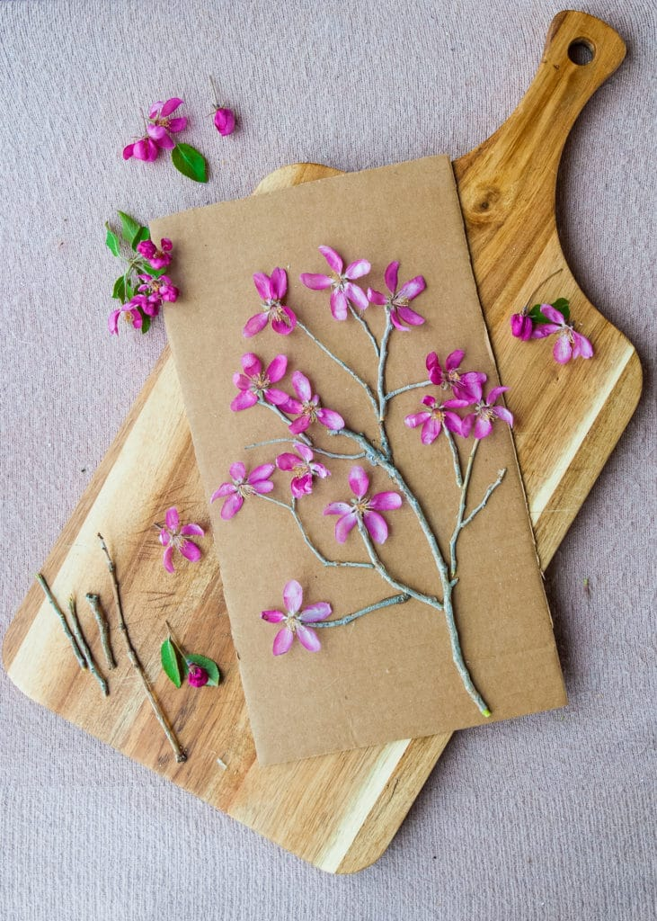

Read a book outside.

Make a birdfeeder. Please see link to help make these. 

Place some stones in your garden and check to see if minibeasts come to live there!

Play with some toys outside. 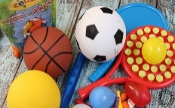

Make a den inside or outside.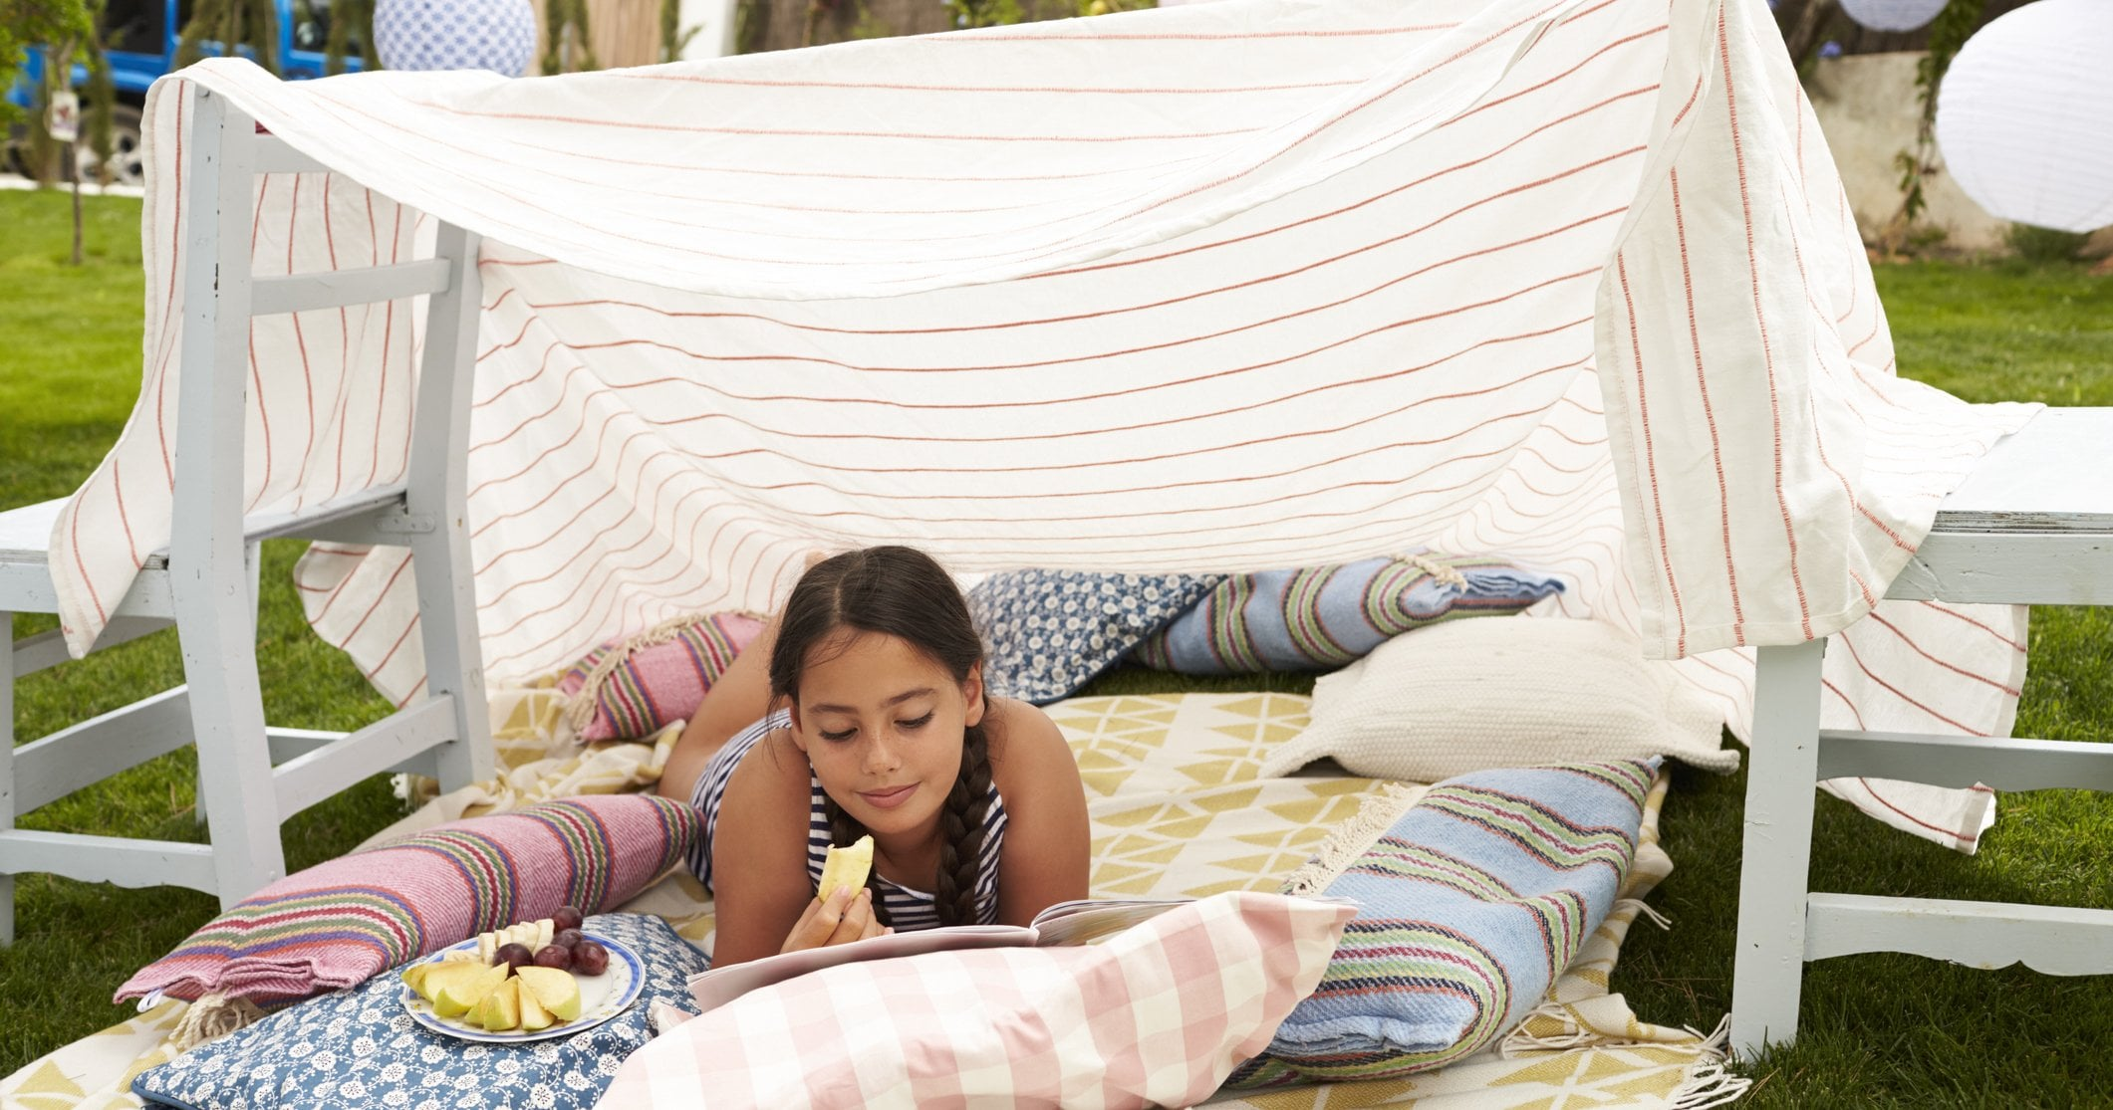e.

Collect some raindrops in a container on a rainy day and use them to water a plant. 

Outdoor learning/play ideas.