June 2020 Home Learning- 30 DAYS OF FUNKY FINGERS Fine Motor Activities Mill Strand IPS
Use cotton buds to write your name or some numbers/ shapes  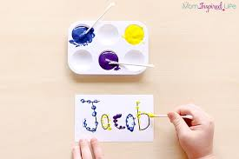 | Create jewellery by threading beads or pasta on a string  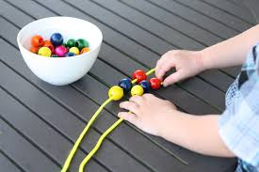 | Carefully place beads or pebbles onto curvy and zig zag lines  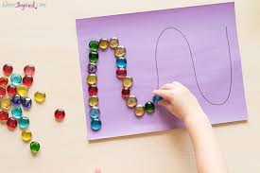 | Make a playdough pet  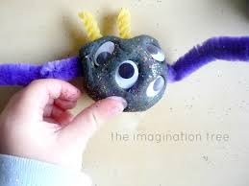 | Practise painting by doing some nail art  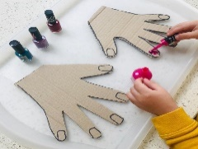
Practise cutting with scissors and playdoh | Use tweezers and pom poms to make shapes  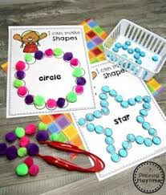 | Make a paper chain  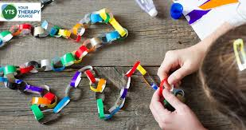 | Make a tube man and give him a funky haircut  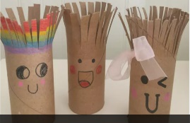 | Practise writing and drawing in salt or sugar  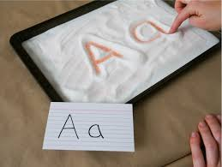
Paint a rock or pebble  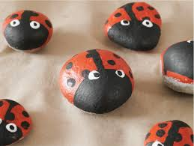 | Design and make your own sandwich, practise spreading.  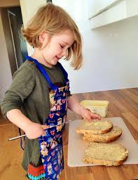 | Thread pipe cleaners or spaghetti in a colander  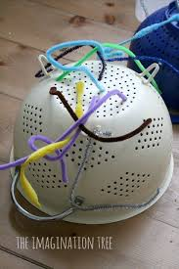 | Build a model with clothes pegs.  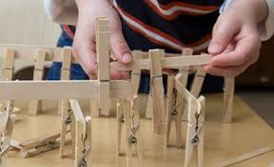 | Practise using zips and buttons  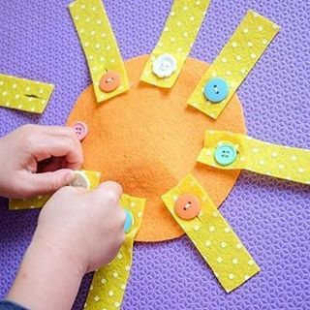
Eat some noodles with chopsticks. Or practise this skill by playing with spaghetti & sticks  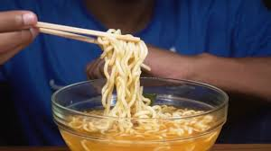 | Your choice!  What did you choose?  _________________________ | Practise using your knife and fork to chop and eat your own meals  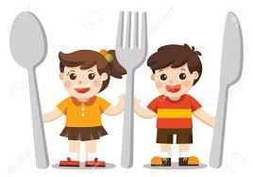 | Your choice!  What did you choose?  ___________________ | Draw or write EVERYDAY of the challenge.  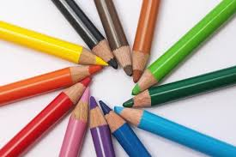
Please take pictures of your work and send them to us on seesaw!

