June 2020 Home Learning- 30 DAYS WILD #30 days wild #outdoorlearning Mill Strand IPS
Fill a nature box(a small cardboard box)  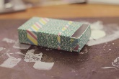 | Go skipping  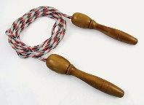 | Read a book outside | Lie on the grass and watch the clouds(what shapes can you see?)  _______________  _______________  _______________ | Make a nature picture using things from nature.  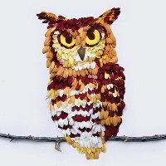
Visit the beach, remove some litter  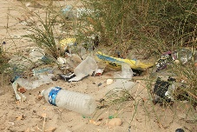 | Plant something/water plants  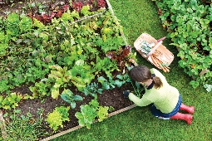 | Go out on your bike/scooter/skateboard  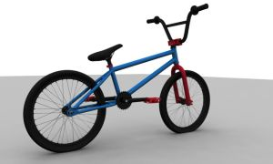 | Go for a walk in a forest, find an interesting stick  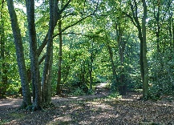 | Make a den in your garden/outdoors  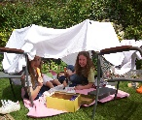  This Photo by Unknown Author is licensed under CC BY-NC-ND
Have a picnic  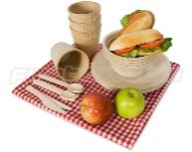 | Paddle in water/surf/find a mermaids purse/shell  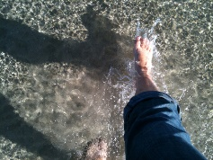 | Catch raindrops in a container, use it to water a plant | Write your name with natural materials  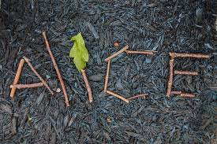 | Play with some toys outside
Scavenger hunt  Make a list of 8 things you would like to find  This Photo by Unknown Author is licensed under CC BY-NC-ND | Your choice!  What did you choose?  _________________________ | Keep checking your minibeast home/hotel!  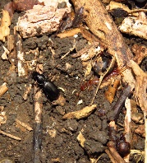 | Your choice!  What did you choose?  ___________________ | Make a daisy chain/make a sound by placing a blade of grass between your two thumbs  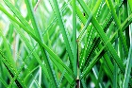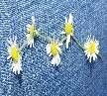  This Photo by Unknown Author is licensed under CC BY-NC-ND
Please take pictures of your work and send them to us on seesaw! Pictures will also we added to facebook/twitter to promote #30dayswild, have fun!

