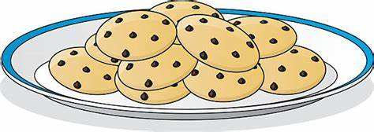
Addition Facts to 6

Resources:
- Six identical items (eg. biscuits, raisins, cubes, paper clips, anything that you have!)
- Two items to sort them on (eg. plates)

Ask your child to explore all of the different ways that they can arrange the 6 items between the plates, eg.
0 on one plate and 6 on the other
5 on one plate and 1 on the other
4 on one plate and 2 on the other
Etc…
Ask them to record the different ways to make 6 on a piece of paper by writing the sums, eg.
0 + 6
5 + 1
4 + 2
Etc…
Use these practical resources to help your child to complete the activity sheet – they have to draw 6 freckles on Pinocchio’s face, arranging them in different ways and recording the matching sum.

