Adventures

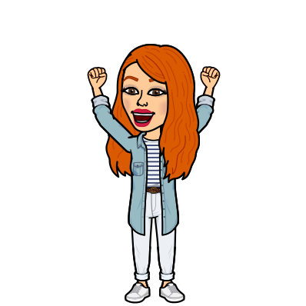
with flat Miss Robinson!
Hello Year 2,
How have you been?
I miss you a tonne,
So let’s have some fun!

I have come to see you,
And although I am flat and small,
You can show me around,
We’ll have a ball!

But why are you flat?
I hear you say,
Well an evil villain shrunk me yesterday!

Here is what you need to do:
Take me with you to lots of places.
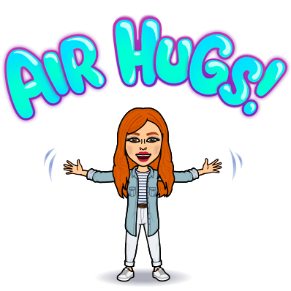
Then take a picture of me,
It can be with things or your lovely faces!

Please send the pictures my way,
I can’t wait to see
All the fun things we do,
Back together, me and you!

