Fruit and Vegetable Characters
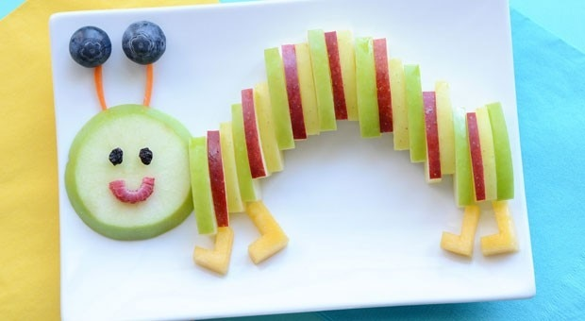
Have some fun being creative with different fruits and vegetables you have in your house. Can you make a fruit/vegetable face out of real fruits and vegetables or photographs? Can you make a picture?
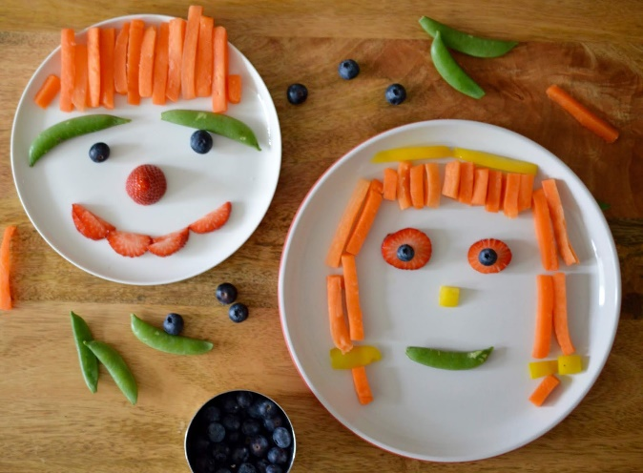

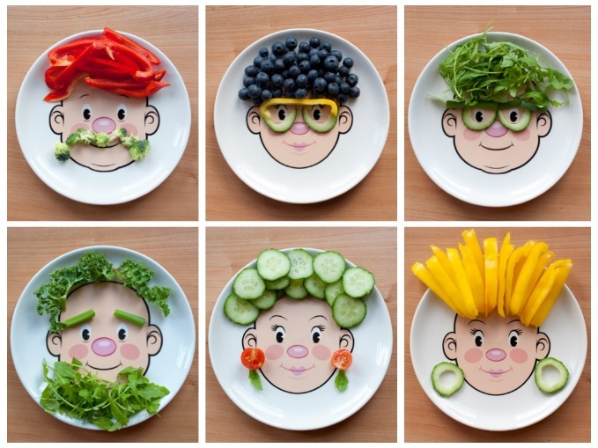
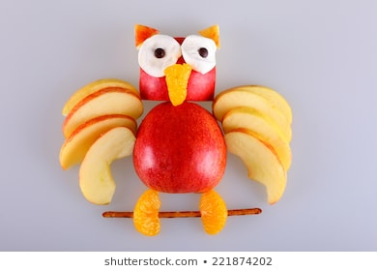

Look up the artist Giuseppe Arcimboldo for inspiration!
