Indoor Scavenger Hunt
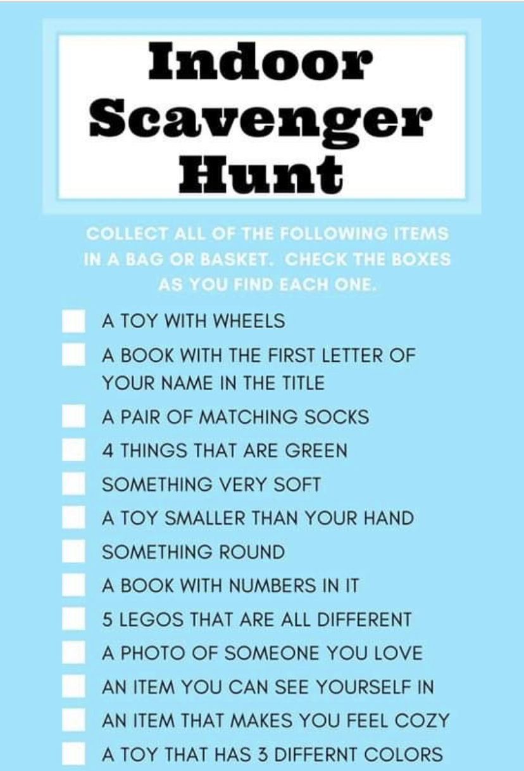
Tick each item off as you find it

