**Life cycle**

**of an**

**Apple Tree**

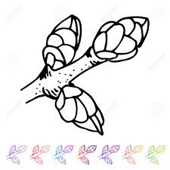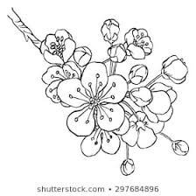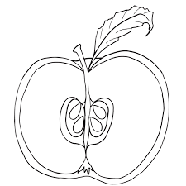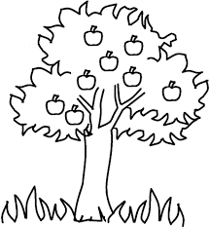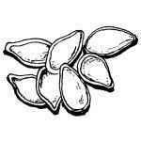Carefully cut out the pictures and arrange them in order. Use the word bank to label each picture.

Word Bank

apple

seeds

buds

blossom

tree