**Flat Teacher Adventures**

**My Flat Teacher**

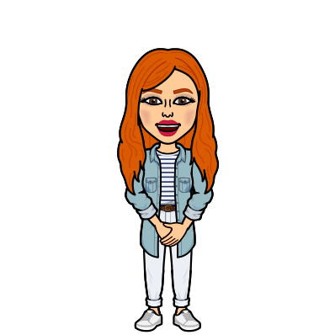Choose your favourite Miss Robinson and cut me out: