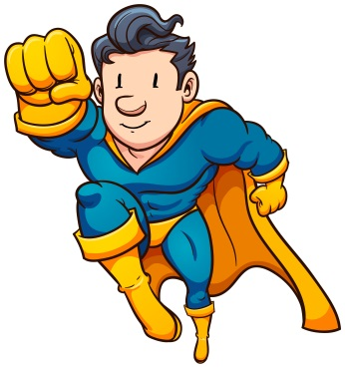
My super hero
What is a hero?
____________________________________________________
My super hero is _________________,

because ________________________

_______________________________

_______________________________.

