Roll and spell – out loud!
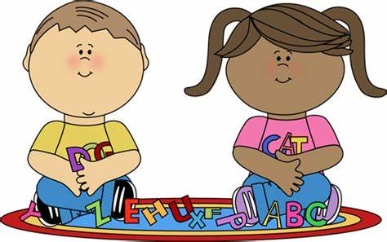

Roll the dice. Spell your spelling word according to the matching die number. Say your word out loud when you finish.

Whisper the word in a quiet voice
Spell the word in a robot voice
Sing the word in an operatic voice
Spell the word in a cackling witches voice
Spell the word LOUDLY!
Spell the word in a posh voice

