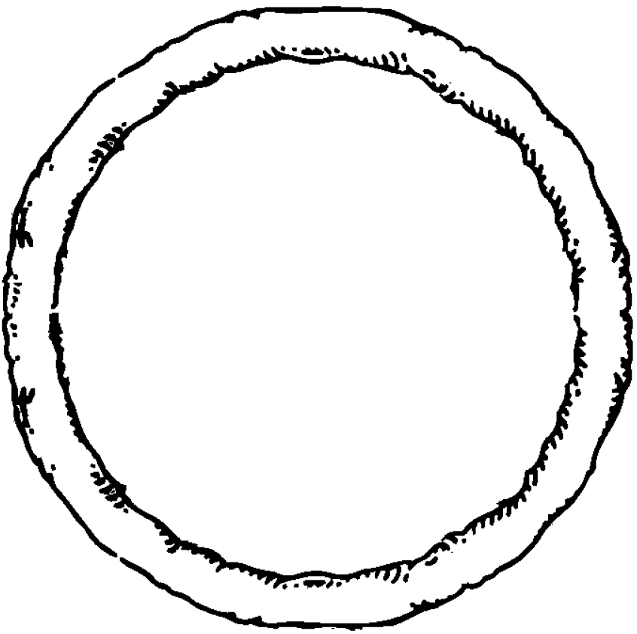

My Recipe for Shape Pizza

I used ________ circles.

I used ________ squares.

I used ________ triangles.

I used ________ rectangles.

I used ________ ovals.