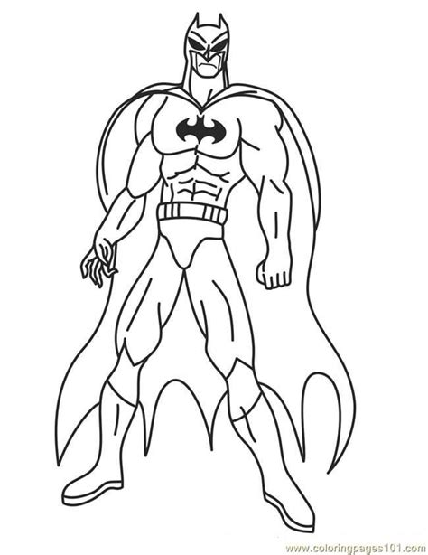
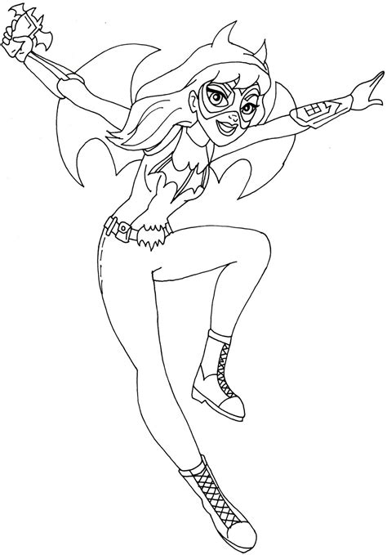
Superheroes are brave and can say sorry
Sometimes when we feel angry, we do and say things that we don’t mean to.
Although it can be really difficult, it’s important to say sorry for those things.

I can be brave and
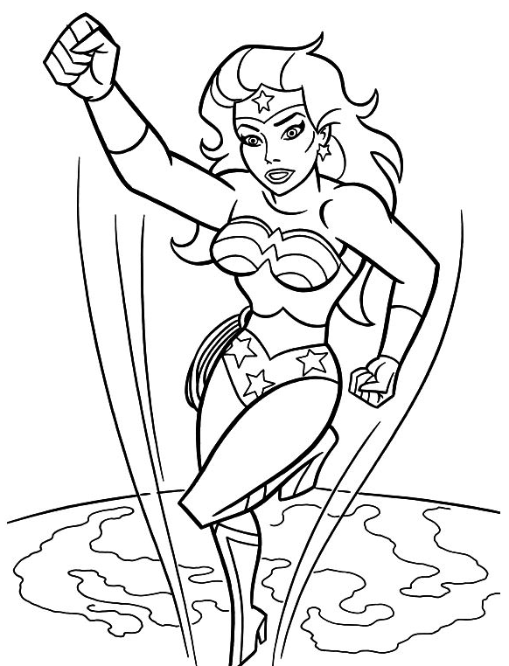
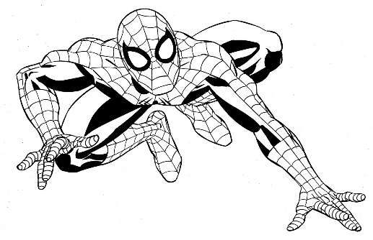
say sorry for…

