|  |  |
| --- | --- |
| **Item** | **How many?** |
|  |  |
|  |  |
|  |  |
|  |  |

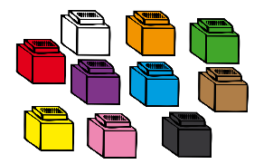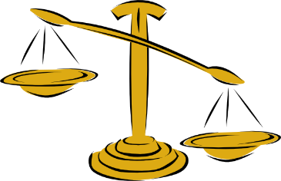

**Use balance scales to find out how many *(your chosen weighing objects)* each item weighs.**

Name………………………………

**How much does it weigh?**