Items I weighed with:  Cubes/pasta shapes/beads etc… | Prediction  How many do you think it will weigh? | Weight  How many does it actually weigh?
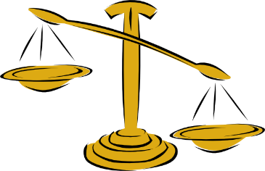
Finished weighing? Find some more objects that weigh the same amount of cubes/pegs/treasure/pom poms/pasta and list them!
Name………………………….
Make a prediction, then use balance scales and different weighing objects to find out how much your object weighs.
How much does it weigh?

