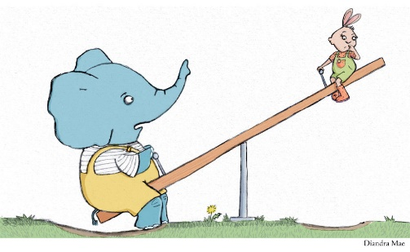

Can you draw/write the items you weighed into the correct box?

Heavier or lighter?

My comparison item is:

Heavier

Lighter