[](http://www.google.co.uk/url?sa=i&rct=j&q=&esrc=s&frm=1&source=images&cd=&cad=rja&uact=8&ved=0CAcQjRw&url=http%3A%2F%2Fwillenaflewelling.com%2F&ei=KmbrVOx4pcbsBsrHgKgB&bvm=bv.86475890,d.ZGU&psig=AFQjCNEGH6YjMqpwHDJa_bffXR8GfMYziw&ust=1424799652191131)[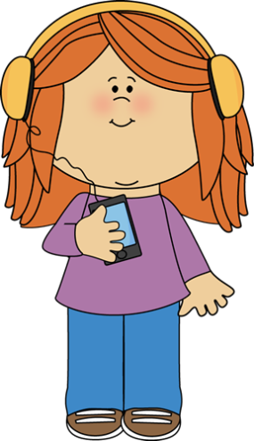](http://www.google.co.uk/url?sa=i&rct=j&q=&esrc=s&frm=1&source=images&cd=&cad=rja&uact=8&ved=0CAcQjRw&url=http%3A%2F%2Fwww.clipartpanda.com%2Fcategories%2Fkids-listening-clipart&ei=b2brVLCTGLKu7AbdzYGgDQ&bvm=bv.86475890,d.ZGU&psig=AFQjCNEGH6YjMqpwHDJa_bffXR8GfMYziw&ust=1424799652191131)Year 2 Sound Map

Me